**SHARE PLATE - Give a Meal Today!**

**Application development Report Submitted.**

**In partial fulfillment of the requirements for the award of the degree of**

**Bachelor of Technology**

**In**

**Information Technology**

**By**

**M. Vamshi Yadav - 22N31A3333**

**B. Vamshi - 22N31A3305**

**P. Harish -   22N31A3345**

Under the esteemed guidance of

MR.R.CHANDRA SHEKAR

MS.M.SWARNANJALI



**Department of Information Technology**

# Malla Reddy College of Engineering and Technology

(Autonomous Institution-UGC, Govt. of India)

(Affiliated to JNTUH, Hyderabad, Approved by AICTE, NBA&NAAC with ‘A’ Grade) Maisammaguda, Kompally, Dhulapally, Secunderabad – 500100

Website: [www.mrcet.ac.in](http://www.mrcet.ac.in/)



# **Malla Reddy College of Engineering and Technology**

**(Autonomous Institution-UGC, Govt. of India)**

(Affiliated to JNTUH, Hyderabad, Approved by AICTE, NBA&NAAC with ‘A’ Grade) Maisammaguda, Kompally, Dhulapally, Secunderabad – 500100

Website: [www.mrcet.ac.in](http://www.mrcet.ac.in/)

## **CERTIFICATE**

This is to certify that this is the bonafide record of the Application Development -1 entitled “**SHAREPLATE- Give a Meal Today”.** Submitted by **M.Vamshi (22N31A3333), B.Vamshi (22N31A3305) and P.Harish (22N31A3345)** B. Tech in the partial fulfillment of the requirements for the degree of Bachelor of Technology in Information Technology, Department of IT during the year 2024-2025.

**Internal Guide Head of the Department**

**External Examiner**

## **TABLE OF CONTENTS**

|  |  |  |
| --- | --- | --- |
| **S. NO** | **TITLE**  **ABSTRACT** | **PG. NO** |
| **1** | **INTRODUCTION** |  |
|  | 1.1 PURPOSE AND OBJECTIVES |  |
|  | 1.2 EXISTING AND PROPOSED SYSTEM |  |
| **2** | **APPLICATION DESCRIPTION** |  |
| * 1. HARDWARE AND SOFTWARE REQUIREMENTS   2. METHODOLOGY | | |
| **3** | **SOURCE CODE** |  |
| **4** | **RESULTS** |  |
| **5** | **CONCLUSION & ENHANCEMENTS** |  |
|  | **BIBLIOGRAPHY** |  |

## **ABSTRACT**

In a world where food waste and hunger coexist, SharePlate acts as a vital link connecting surplus food with those in need. This innovative web-based platform, developed using HTML, CSS, and MongoDB, empowers individuals to donate leftover food by easily listing essential details and mapping its precise location. Those in need can effortlessly search for specific food items by name and access comprehensive details, including exact locations, through an integrated map feature. By leveraging a community-driven approach to food distribution, SharePlate aims to significantly reduce food waste and ensure that surplus food reaches those who need it most. The platform is designed to provide a lightweight and accessible user experience by minimizing the use of complex JavaScript functionalities, making it accessible to a broad audience, and fostering a culture of sharing and sustainability.

**INTRODUCTION**

**1.1 PURPOSE AND OBJECTIVES**

**Purpose:**

The primary purpose of SharePlate is to bridge the gap between food surplus and those in need, reducing food waste while addressing hunger in communities. By providing a user-friendly platform for food donations, SharePlate enables individuals, businesses, and organizations to easily share excess food, ensuring that it is distributed to people facing food insecurity rather than being discarded. The platform fosters a culture of sharing, sustainability, and social responsibility, aiming to make food redistribution more accessible and efficient.

**Objectives:**

1. **Reduce Food Waste**: Minimize the amount of edible food that goes to waste by providing a platform where surplus food can be quickly and easily donated to those who need it.
2. **Address Hunger**: Connect individuals facing food insecurity with available food resources in their local areas, making it easier for them to find and access food.
3. **Encourage Community Engagement**: Promote a community-driven approach to food distribution, where individuals and organizations actively participate in sharing and redistributing surplus food.
4. **Provide Easy Access to Food Donations**: Ensure that both food donors and recipients can use a simple and intuitive interface to list or find food items, complete with location mapping for easy collection.
5. **Support Sustainability**: Contribute to environmental sustainability by reducing the amount of food waste that ends up in landfills, thereby lowering the overall carbon footprint associated with food disposal.
6. **Create an Inclusive Platform**: Build an accessible platform that can be used by a broad audience, including individuals with limited technological skills or internet access, through its lightweight and minimalist design.

These objectives collectively align with SharePlate's vision to create a more sustainable, equitable food system while fostering a spirit of generosity and care within the community.

**1.2** **EXISTING AND PROPOSED SYSTEM**

**EXISTING SYSTEM**

In the current landscape, food donation and distribution often rely on physical locations such as food banks and shelters, which may have limited reach and accessibility. Existing systems may not efficiently match available food with those in need due to logistical challenges and a lack of technology integration. Key limitations include:

* **Limited Reach**: Traditional food banks may not cover all areas, leaving some individuals without access to donated food.
* **Inefficient Matching**: Difficulty in connecting donors and recipients quickly and effectively.
* **Manual Processes**: Heavy reliance on manual processes for food distribution, leads to inefficiencies.
* **Food Waste**: Excess food often goes to waste due to a lack of timely distribution channels.

**PROPOSED SYSTEM**

* **Enhancement Accessibility**: The online platform allows users to list and find food from anywhere, increasing the reach and impact of donations.
* **Efficient Matching**: Advanced search capabilities and notifications ensure that food reaches recipients quickly and efficiently.
* **Technology Integration**: Utilizes modern web technologies and map integration for a seamless user experience.
* **Community Engagement**: Encourages community participation in reducing food waste and supporting those in need.

**APPLICATION DESCRIPTION**

**1. Overview:**

**SharePlate** is a community-driven web platform designed to reduce food waste by connecting people with surplus food to those who need it. The platform allows users to list leftover or excess food and provides an easy-to-use search feature for individuals looking for food. By integrating location mapping, the platform ensures that food donations can be quickly and easily accessed by the right individuals or groups.

**2. Key Features:**

* **Food Listing**: Users can post food donations, including a description, type of food, and expiration details.
* **Search Functionality**: Those in need can search for specific food items by name and view their availability.
* **Integrated Map**: Each food listing includes location data, allowing users to view the food’s exact location on a map and plan their collection route accordingly.
* **Minimalist Design**: The platform emphasizes simplicity by reducing JavaScript dependencies, ensuring that users with slower internet connections or limited technical experience can easily use the platform.

**3. User Interface & Experience (UI/UX):**

SharePlate’s interface is designed to be intuitive and accessible to all users, with minimal distractions. The use of simple forms, a clear layout, and integrated map features make the process of donating or searching for food straightforward. The user experience is further enhanced by a responsive design that works well across all devices, from desktop to mobile.

**4. Technology Stack:**

* **Frontend**: Built using **HTML** and **CSS**, the platform provides a clean and responsive interface.
* **Backend**: The backend uses **MongoDB** to store data, allowing for efficient management of food listings and user profiles.
* **Maps Integration**: The platform integrates with third-party mapping APIs (such as Google Maps) to provide real-time location services.

**5. Compatibility & Platforms:**

SharePlate is accessible via any modern web browser on desktop and mobile devices. Its lightweight design ensures that it runs smoothly across various platforms without the need for advanced hardware or software.

**6. Use Cases:**

* **Food Donors**: Individuals or businesses can use SharePlate to donate leftover food after events, restaurant operations, or personal meals.
* **Recipients**: Those experiencing food insecurity can use the platform to find nearby food donations, easily navigating to the location using the integrated map.
* **Community Organizations**: Nonprofits and food banks can monitor local food surpluses and coordinate efficient food redistribution efforts.

**7. Security & Privacy:**

SharePlate follows stringent data security practices, ensuring that users’ personal information is stored securely. Only relevant information (e.g., food type and location) is shared publicly to facilitate donations. No sensitive data is collected, and users have the option to remain anonymous while posting food donations.

**2.1 HARDWARE AND SOFTWARE REQUIREMENTS**

* **Software Requirements :**

1. Operating System : Windows 10

2. Languages used : HTML, CSS, JS

3. Web Browser : Chrome, Firefox, Edge

4. Database : Mongo DB

5. Frameworks : Node js

* **Hardware Requirements** :

1. Processor : Intel i5

2. RAM : 8 GB

3. Storage : 512 GB

**2.2 METHODOLOGY**

This section explains the systematic approach taken to develop the platform for donating and receiving surplus food. The methodology is divided into several phases:

**1. Requirement Analysis**

Identified the key stakeholders (donors, receivers, and platform administrators).

Defined the main features and functionalities needed, such as user registration, food listing, donation tracking, and notifications.

Conducted user research to understand donors' and recipients' pain points and expectations.

**2. Design and Planning**

* **Frontend Design**: Designed an intuitive, user-friendly interface to ensure that the platform is accessible to a broad audience. Wireframes and UI mockups were created using tools like Figma.
* **Backend Architecture**: Structured the backend to handle user authentication, real-time food listing updates, and request processing efficiently. Selected Express.js for server-side logic and MongoDB for the database to store food, user, and transaction data.
* **Database Design**: Choose a NoSQL database (MongoDB) to allow for flexibility in data structure. Collections were created for users, food items, and donation transactions.

**3. Development Phase**

* **Frontend Development**: Utilized modern web technologies such as HTML, CSS, JavaScript, and a frontend framework (React or similar) for building interactive user interfaces.
* **Backend Development**: Developed the backend using Express.js to manage user authentication, food listings, and donation workflows. Integrated MongoDB for data storage.

**UML DIAGRAM**

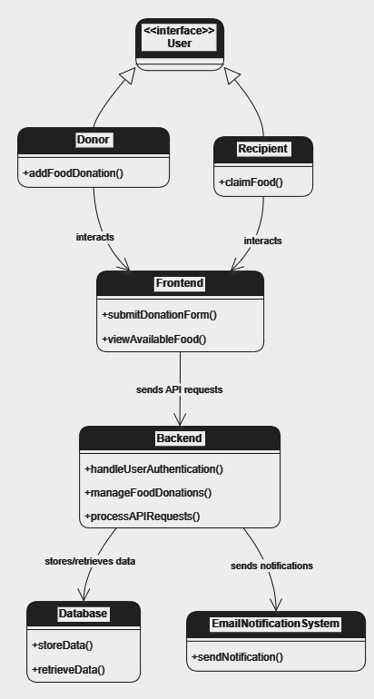

**SOURCE CODE**

**HOME :**

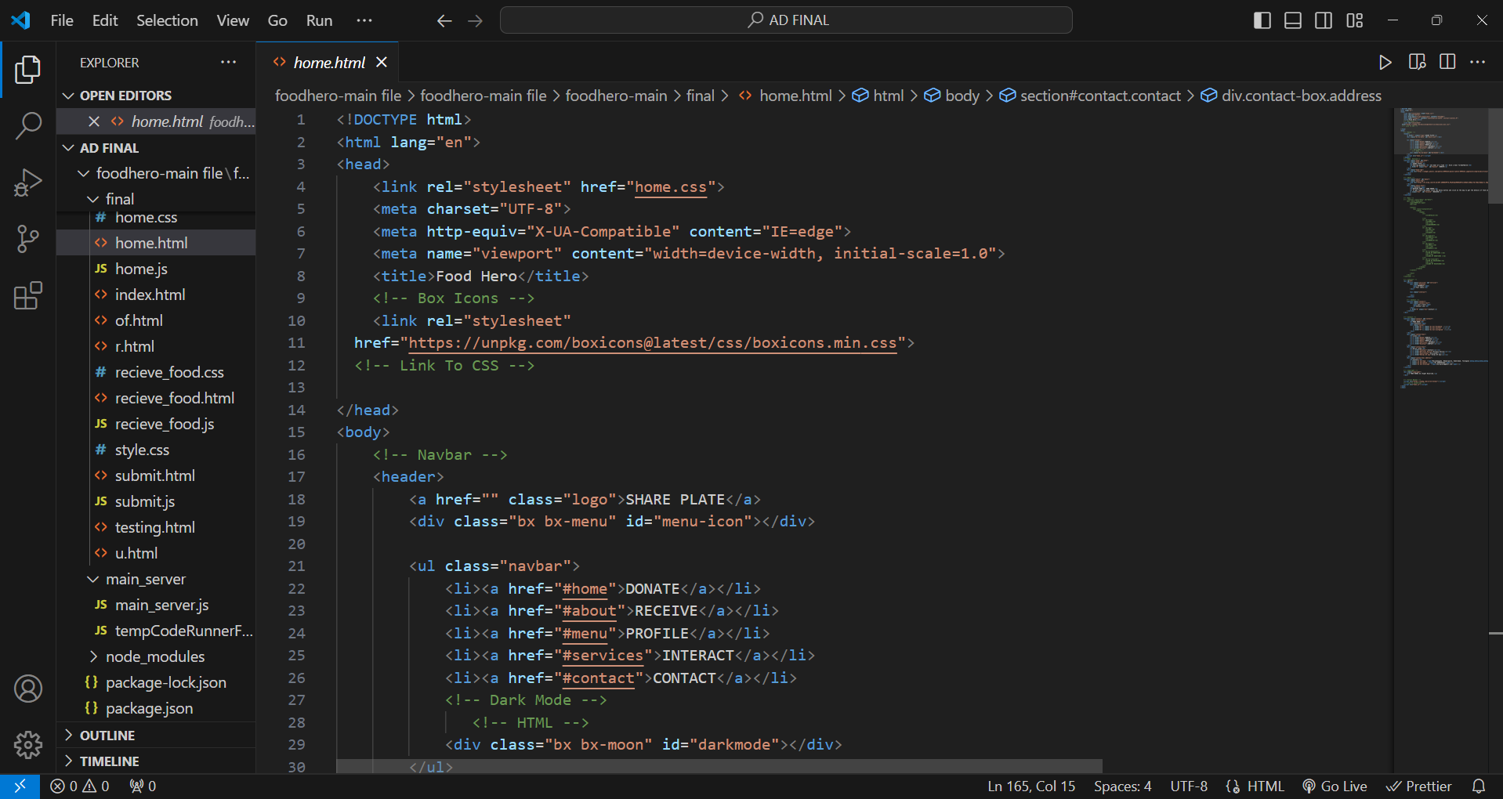

**INDEX :**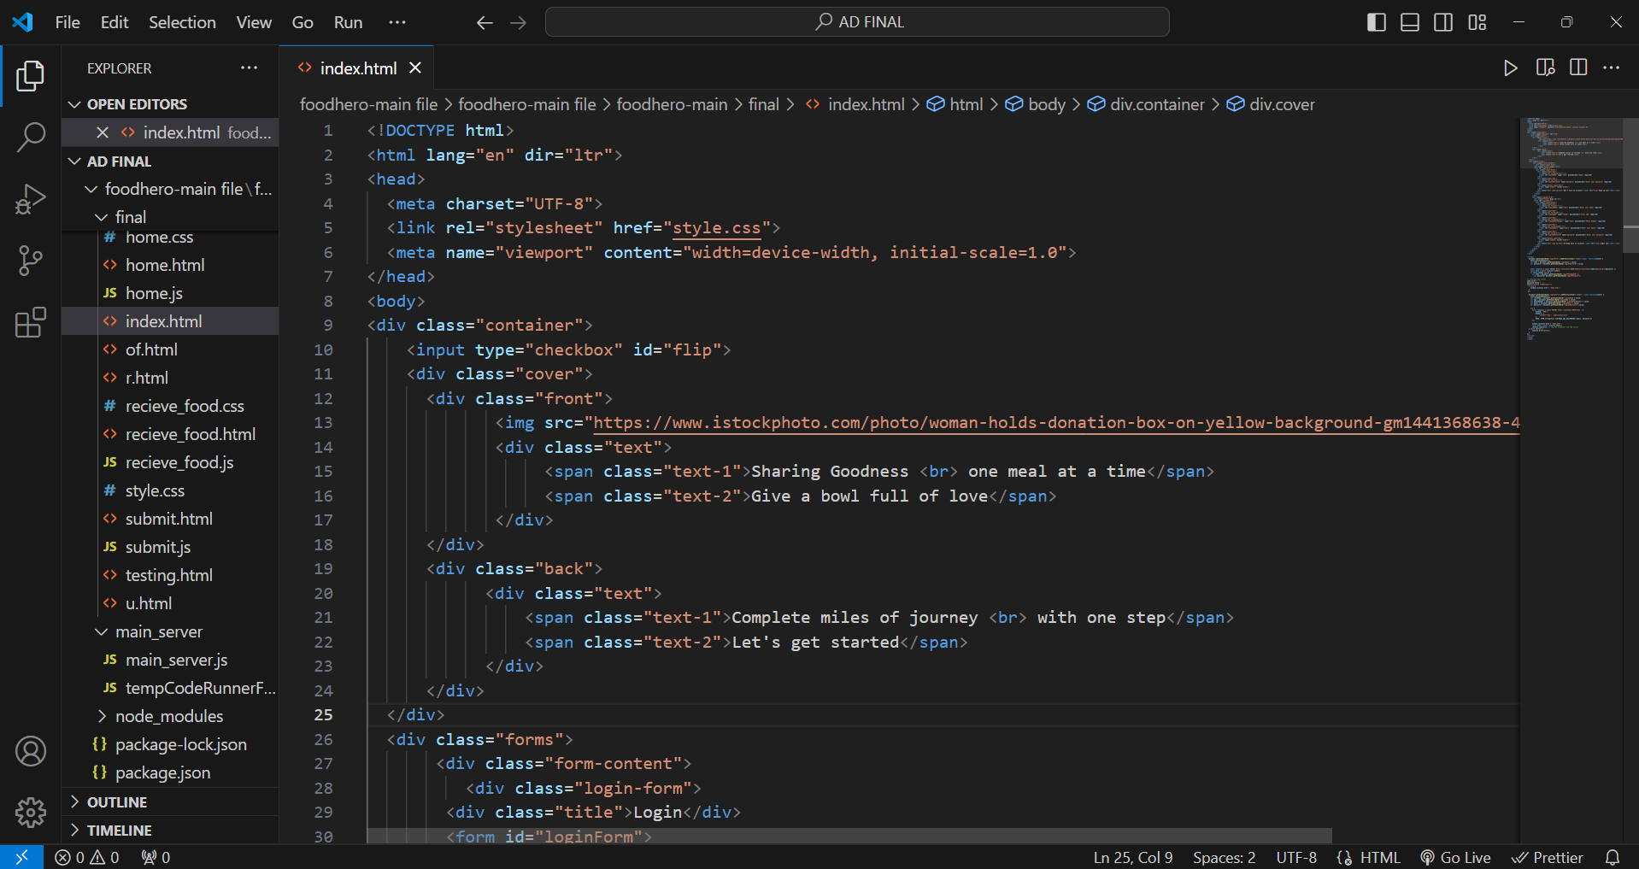

**RESULTS**

LOGIN :

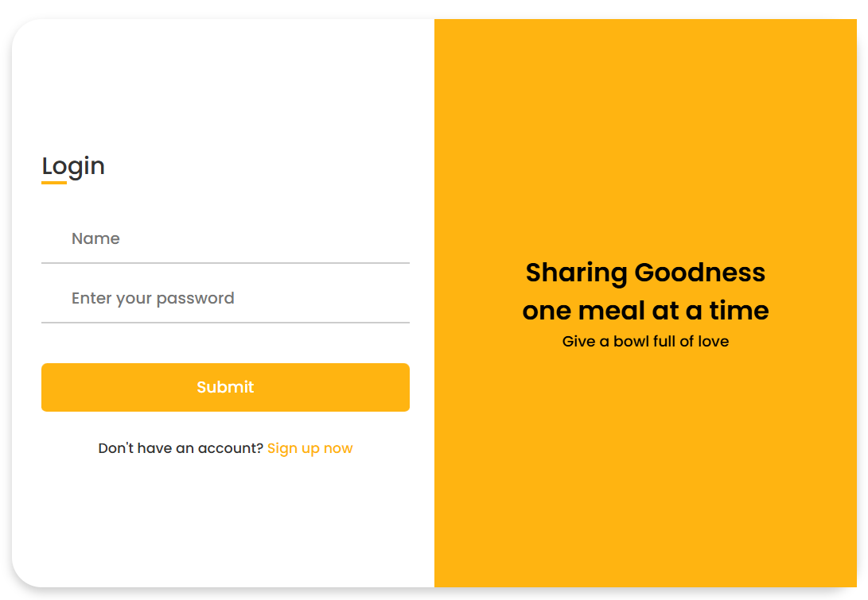

SIGNUP :

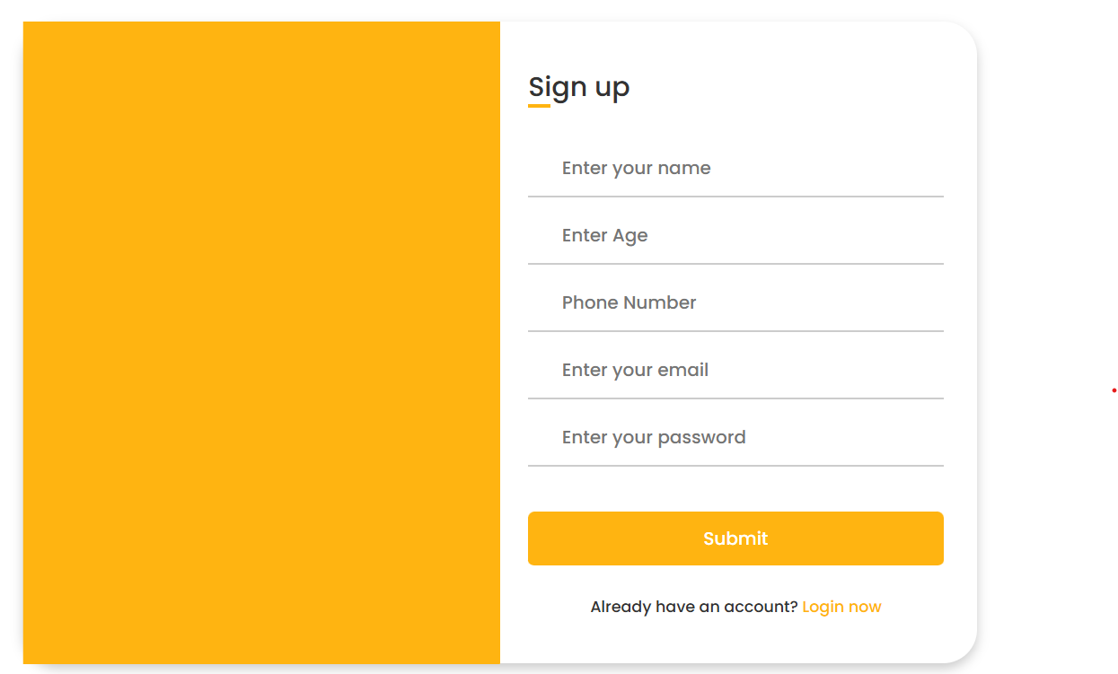

HOME PAGE :

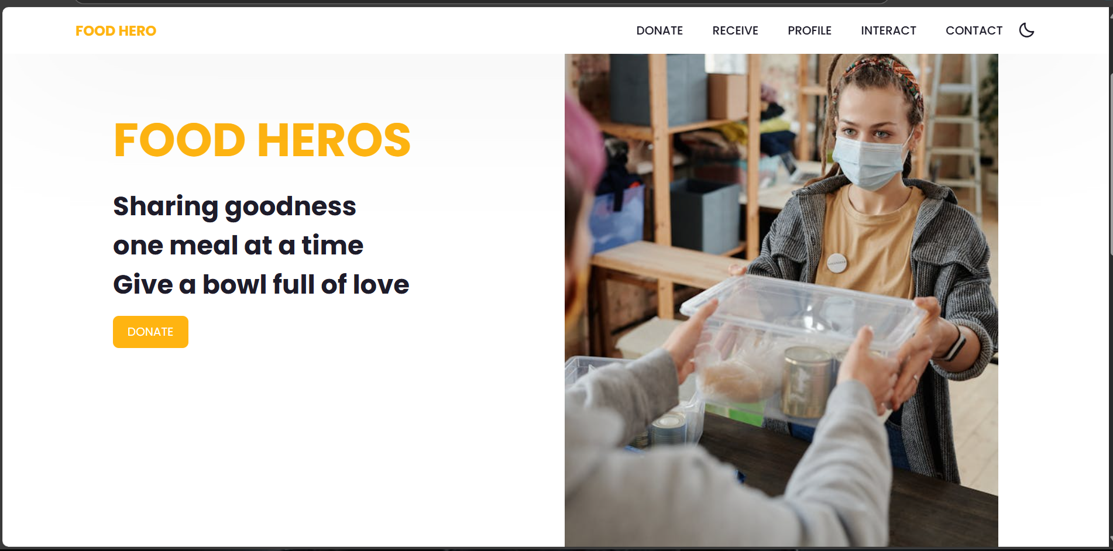

RECIPIENT INTERFACE :

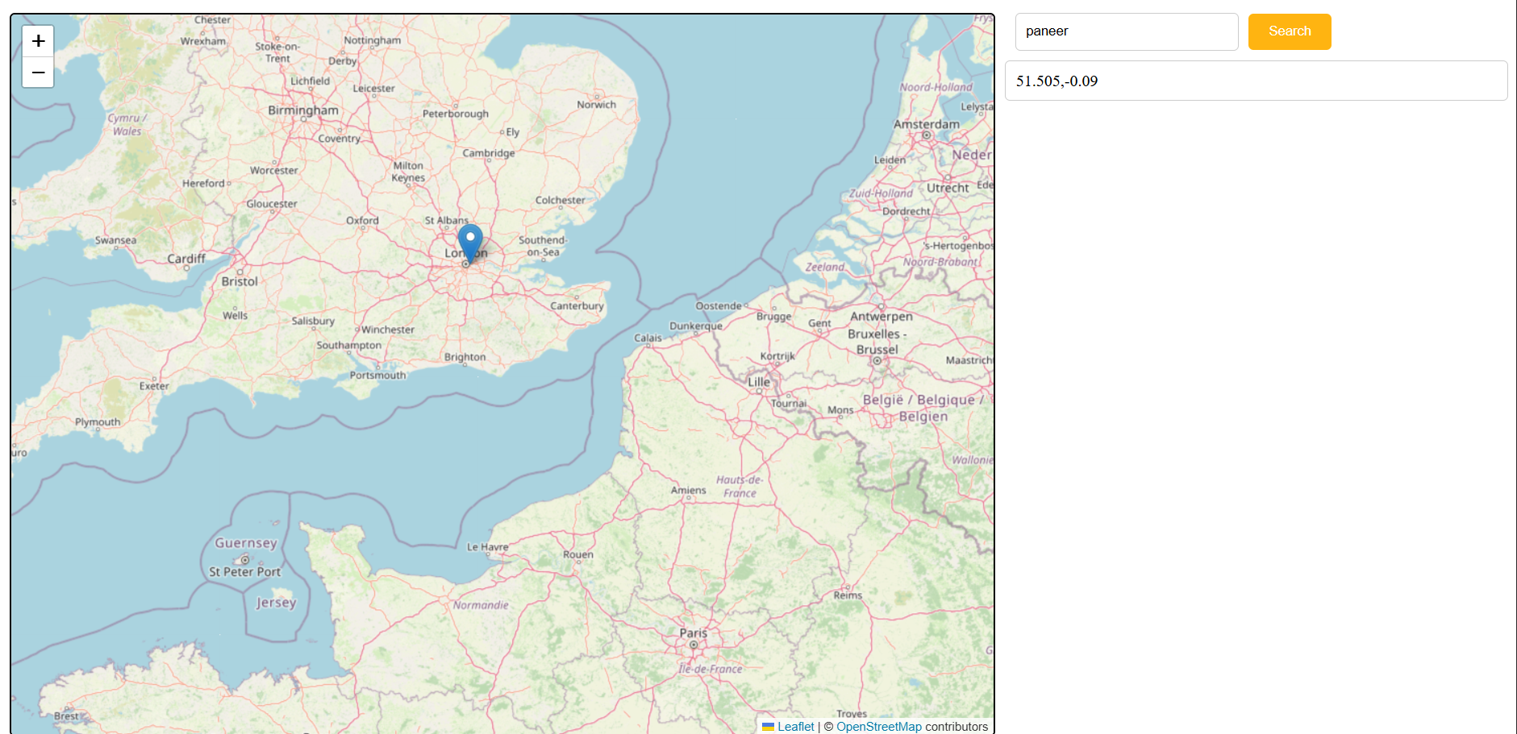

DONER’S INTERFACE :

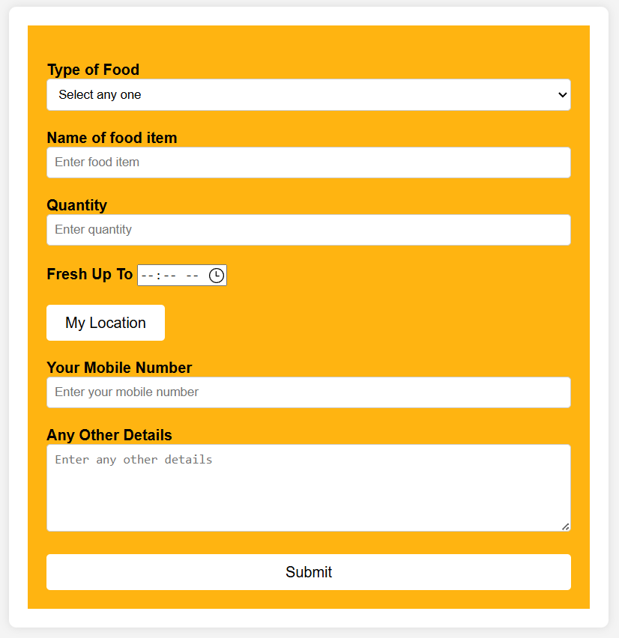

CONCLUSION

SharePlate is an innovative platform to reduce food waste and combat hunger by connecting those with surplus food to those in need. It promotes food security and environmental sustainability through its user-friendly design and advanced features, encouraging active participation from individuals and businesses. By leveraging technology and community-driven solutions, SharePlate seeks to transform food distribution and foster a culture of sharing and responsibility. As the platform expands, it aims to create a significant positive impact, envisioning a future where surplus food is shared, ensuring everyone has access to necessary nourishment. Join SharePlate to make a difference—one plate at a time.

BIBLIOGRAPHY

* **Nodemailer Documentation :**

Official documentation for integrating email-sending functionality using Nodemailer in Node.js.  
<https://nodemailer.com/about/>

* **Express.js Guide :**

A comprehensive guide on building server-side applications using Express.js.  
<https://expressjs.com/en/guide/routing.html>

* **MongoDB Documentation:**

Official MongoDB documentation for setting up and managing a NoSQL database.  
<https://www.mongodb.com/docs/>

* **Node.js Documentation:**

Node.js official documentation covering the basics of building backend systems.  
<https://nodejs.org/en/docs/>